**Data Engineering Assignment – 20**

**CREATING STORAGE ACCOUNT IN AZURE AND CONNECTING IT WITH MICROSOFT AZURE STORAGE EXPLORER:**

First, we need to search for storage account in azure portal.

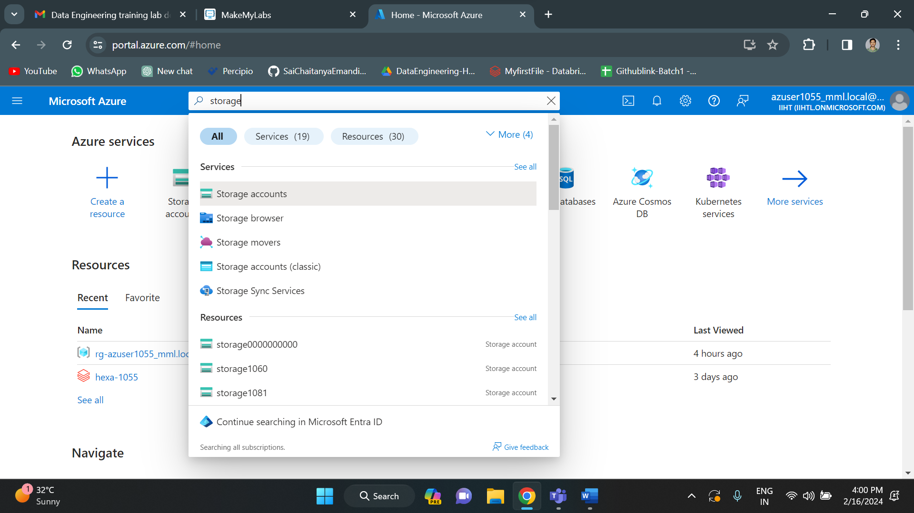

Then we need to click on create to create a storage account.

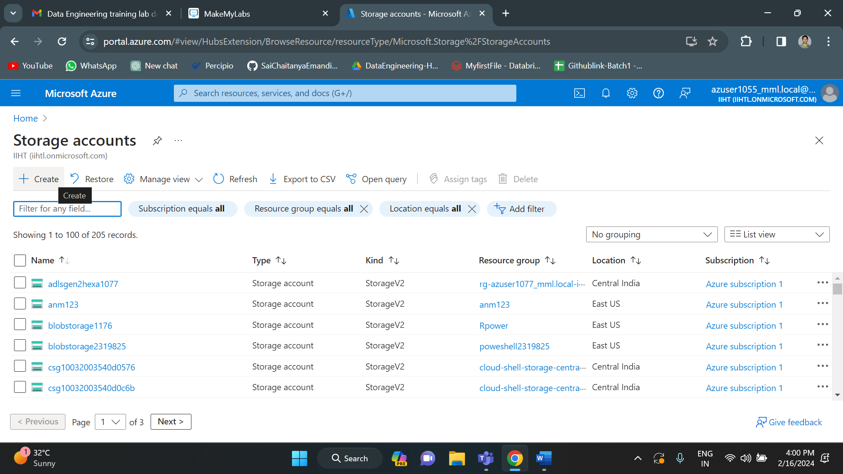

If you want to create azure data lake storage then you need to enable this hierarchical namespace. If not, a normal blob storage account will be created. In this, I am enabling the hierarchical namespace.

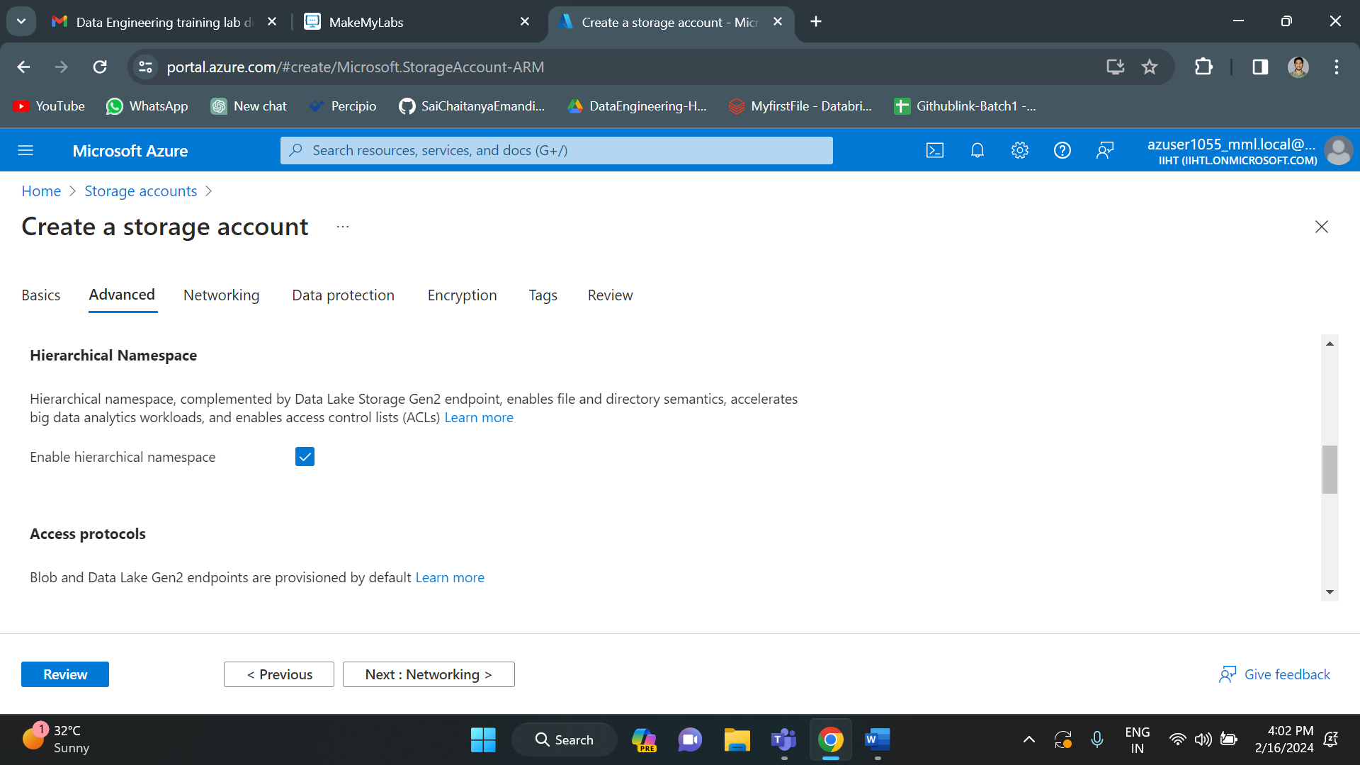

Now we have successfully created a storage account in azure portal. And this is the overview of it.

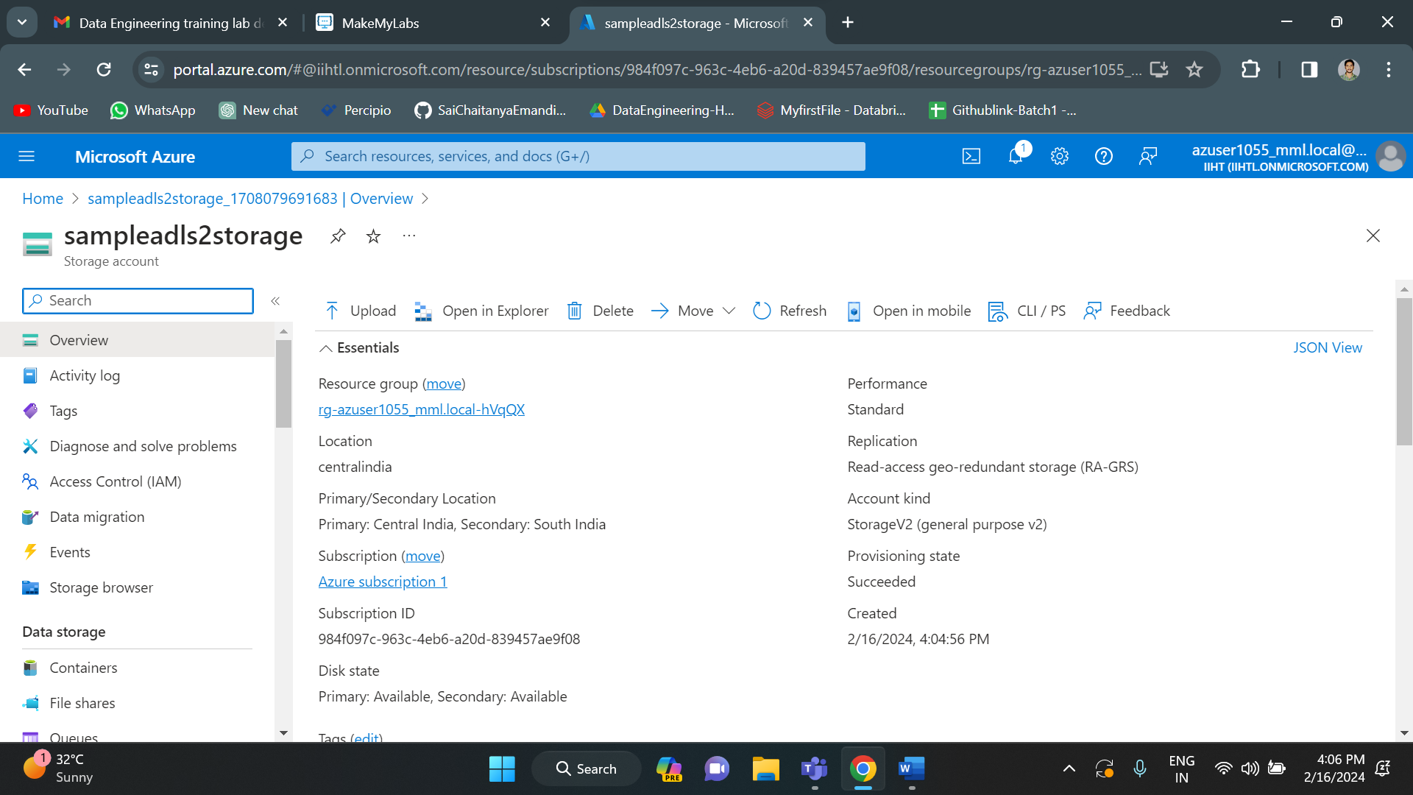

Now in order to storage files, first we need to create a container which contains all the uploaded files. To create a container, on the left side under data storage we will have the option called containers.

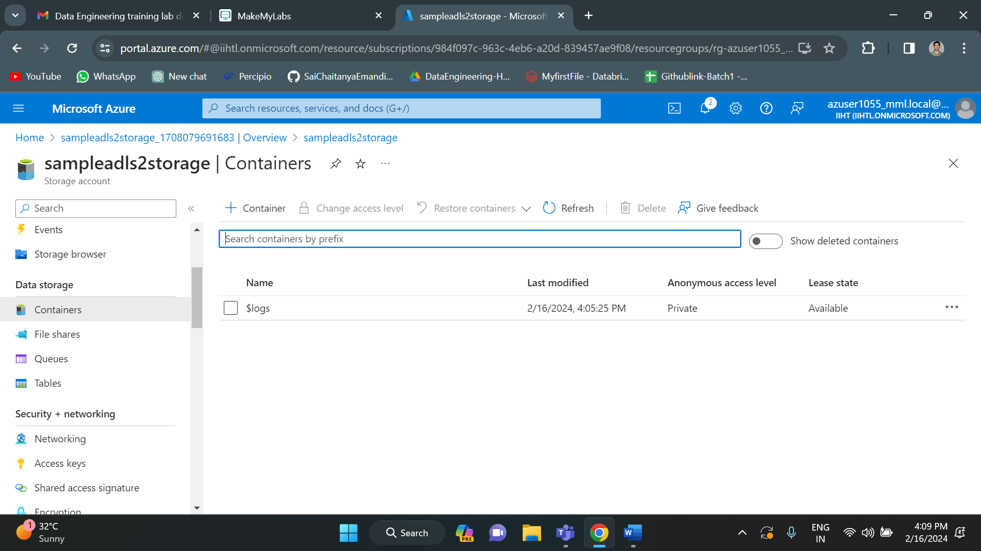

Currently we are not having any containers. If we want to create a container, click on the “+ container” option.

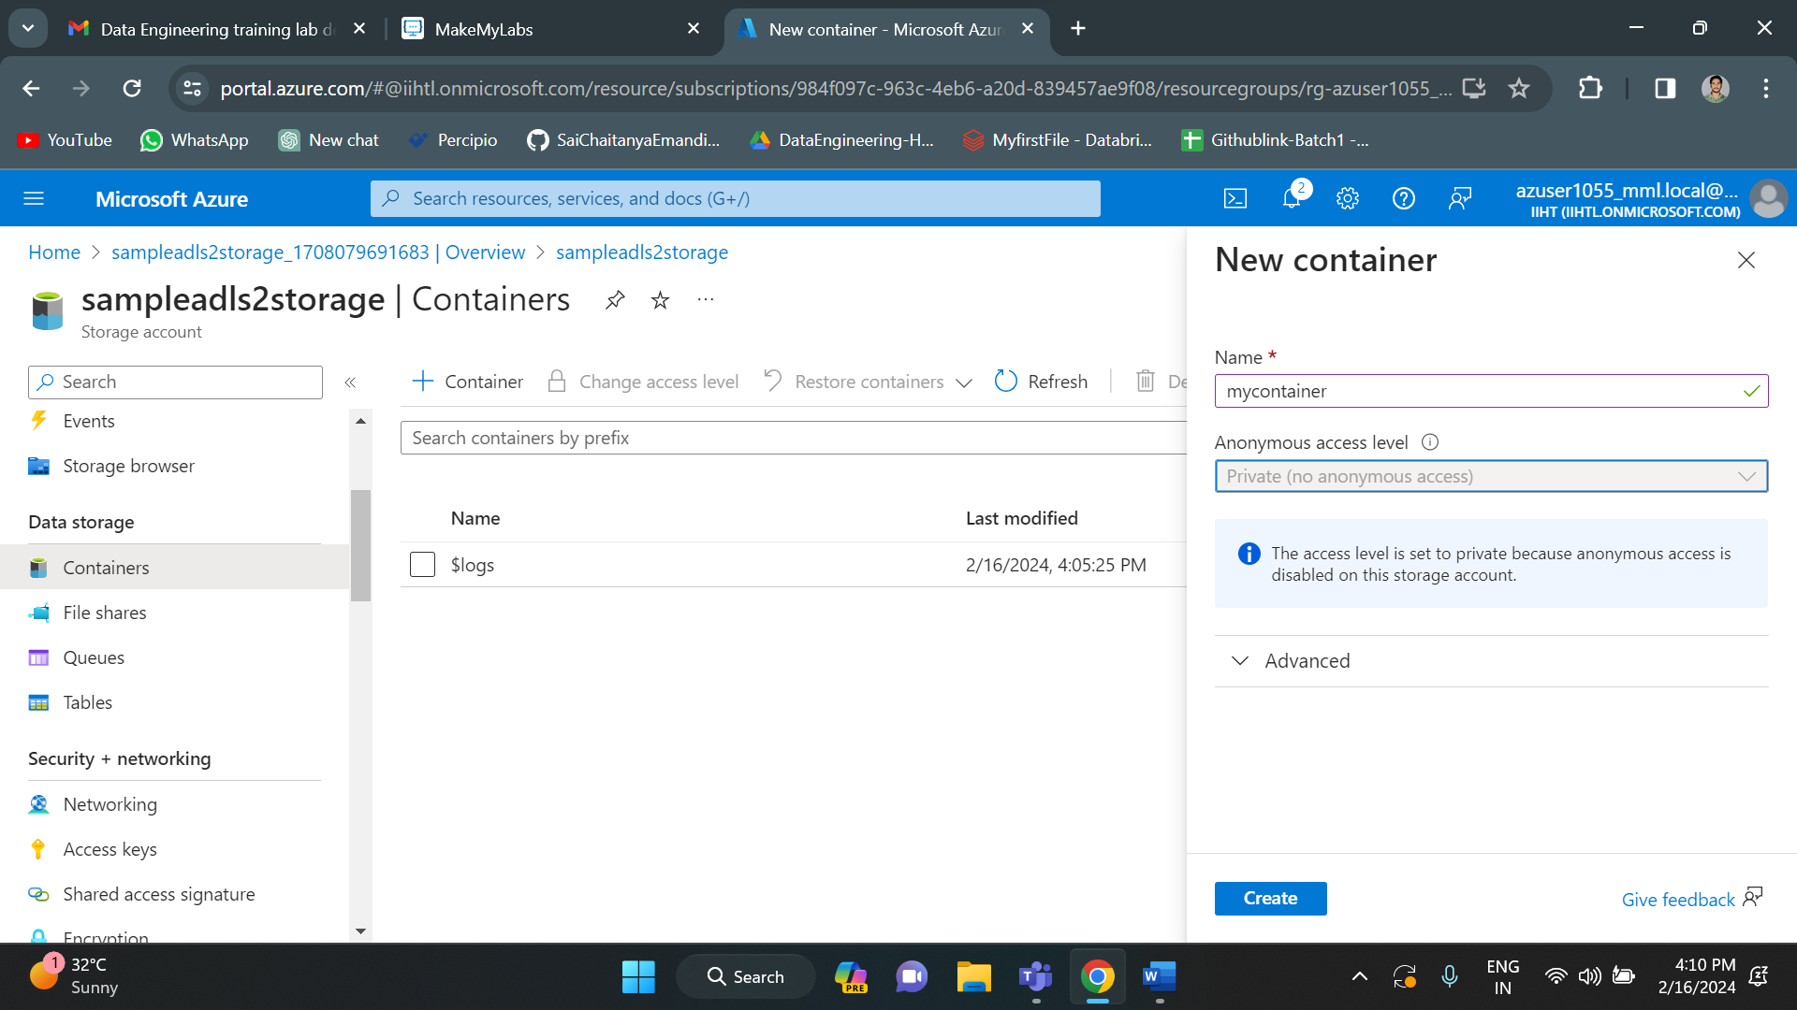

I have given “mycontainer” as container name. Then click on create option below to create a container.

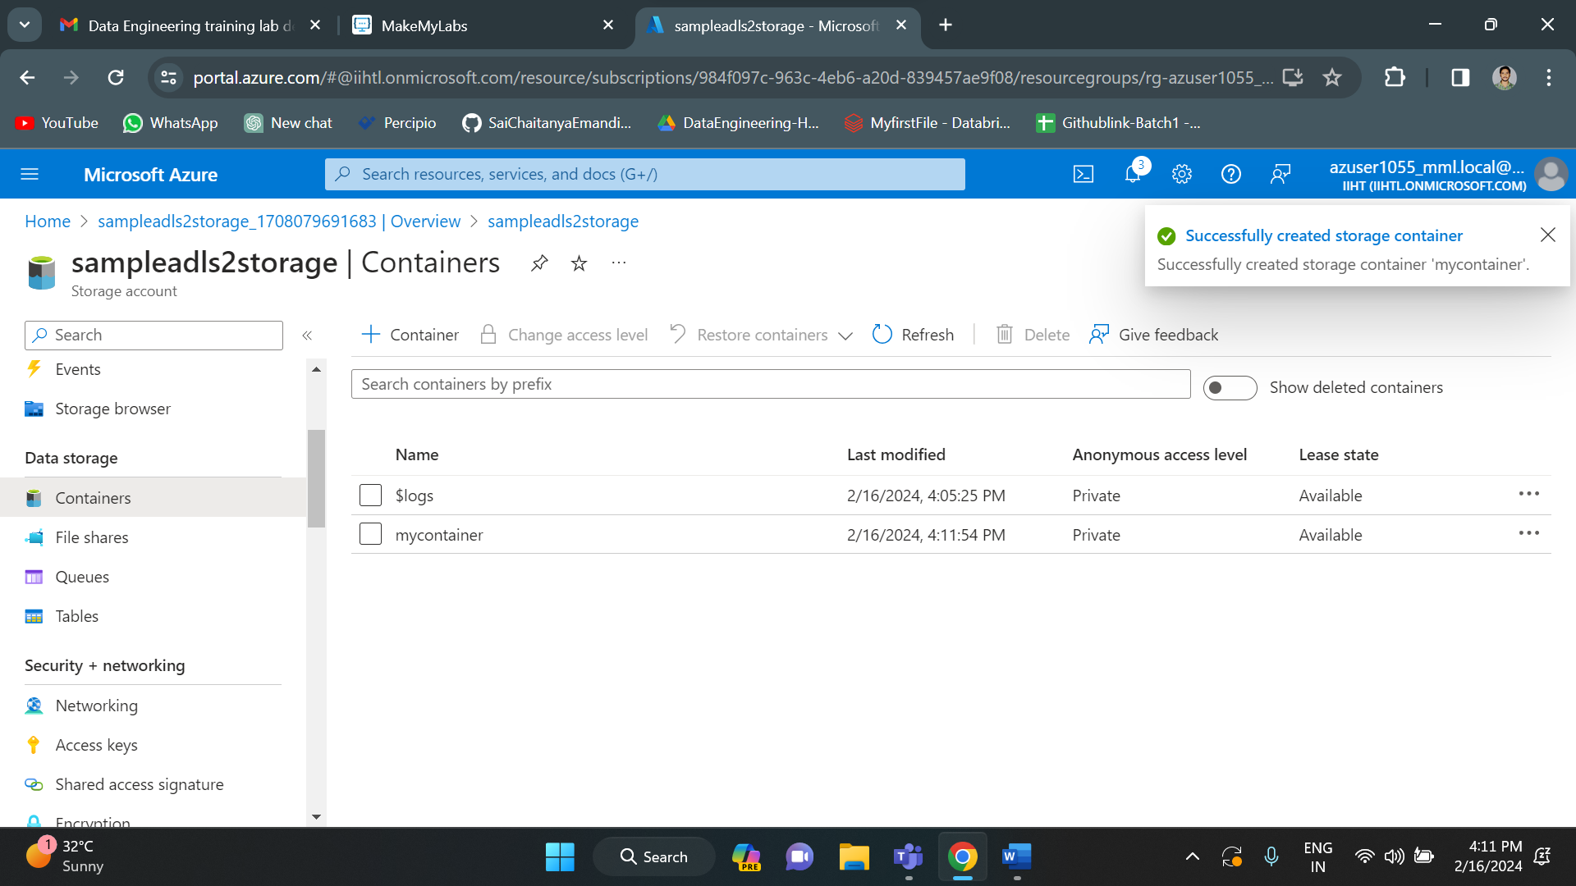

Container successfully created.

Now we can add files into the container or we can create any number of containers. In order to add files into the container, click on the upload option and select required files.

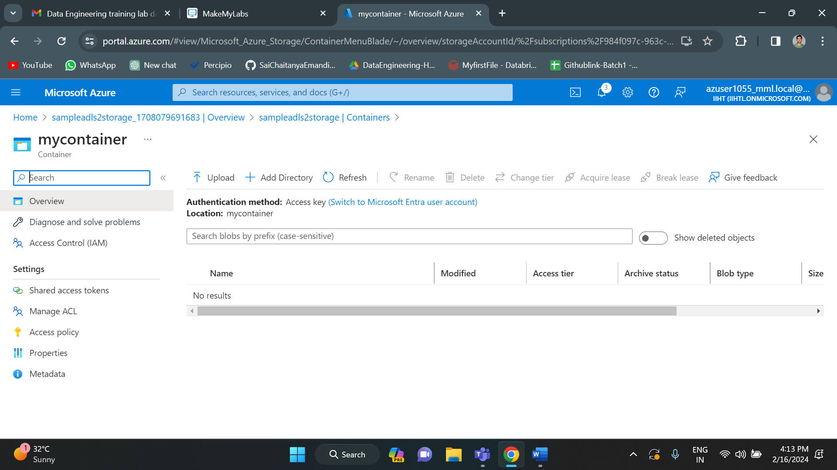

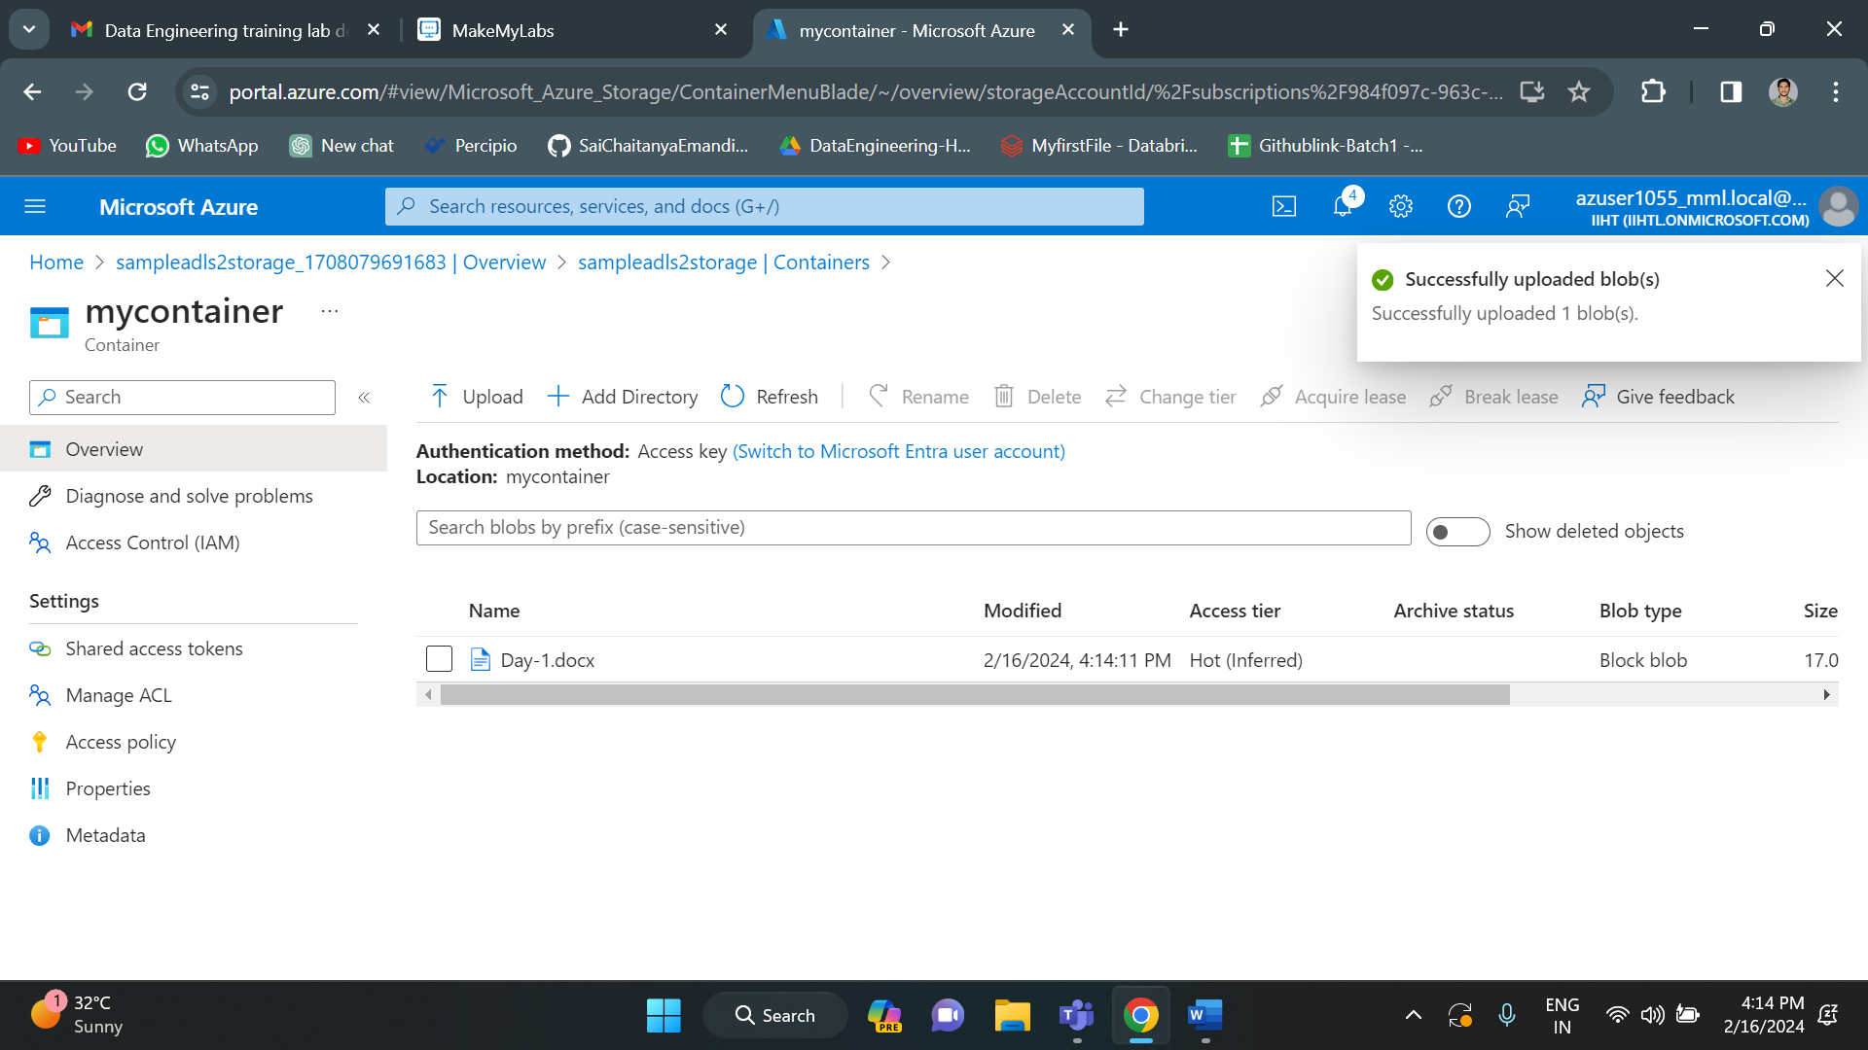

File successfully uploaded.

Now let’s see how to connect this storage account with Microsoft azure storage explorer on local.

Click on connect to azure resources.

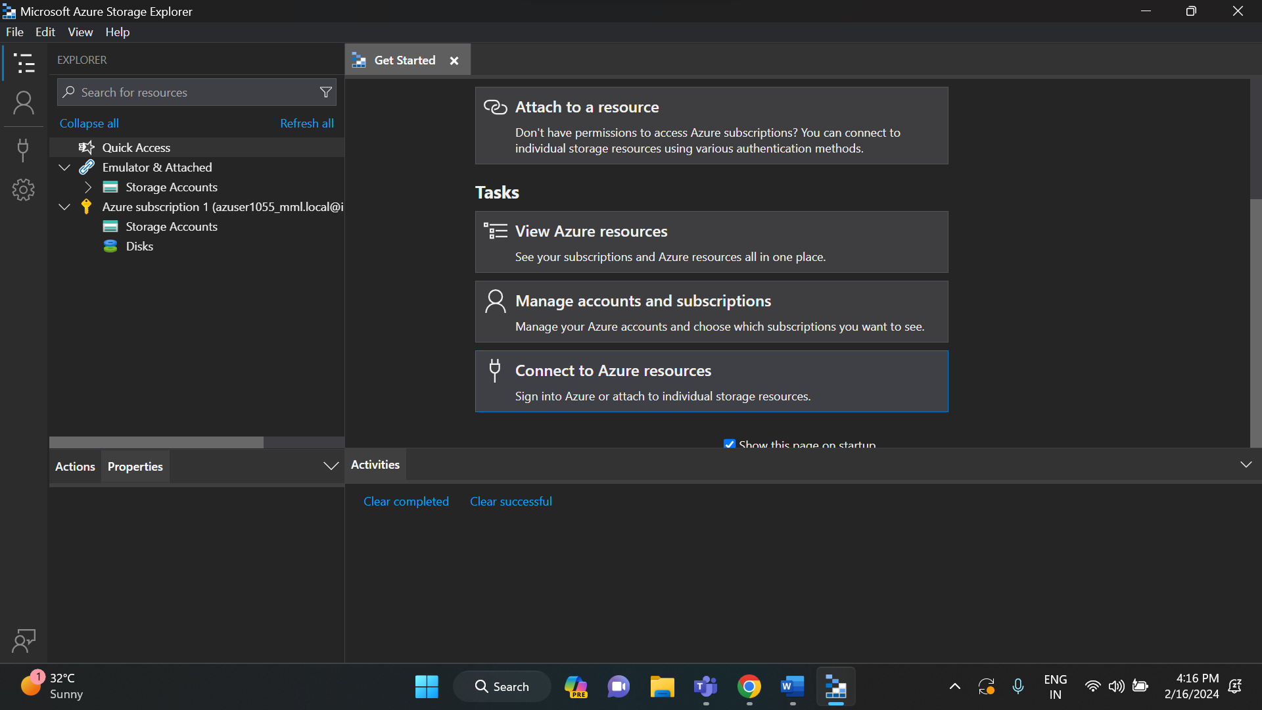

Select the blob container or directory option.

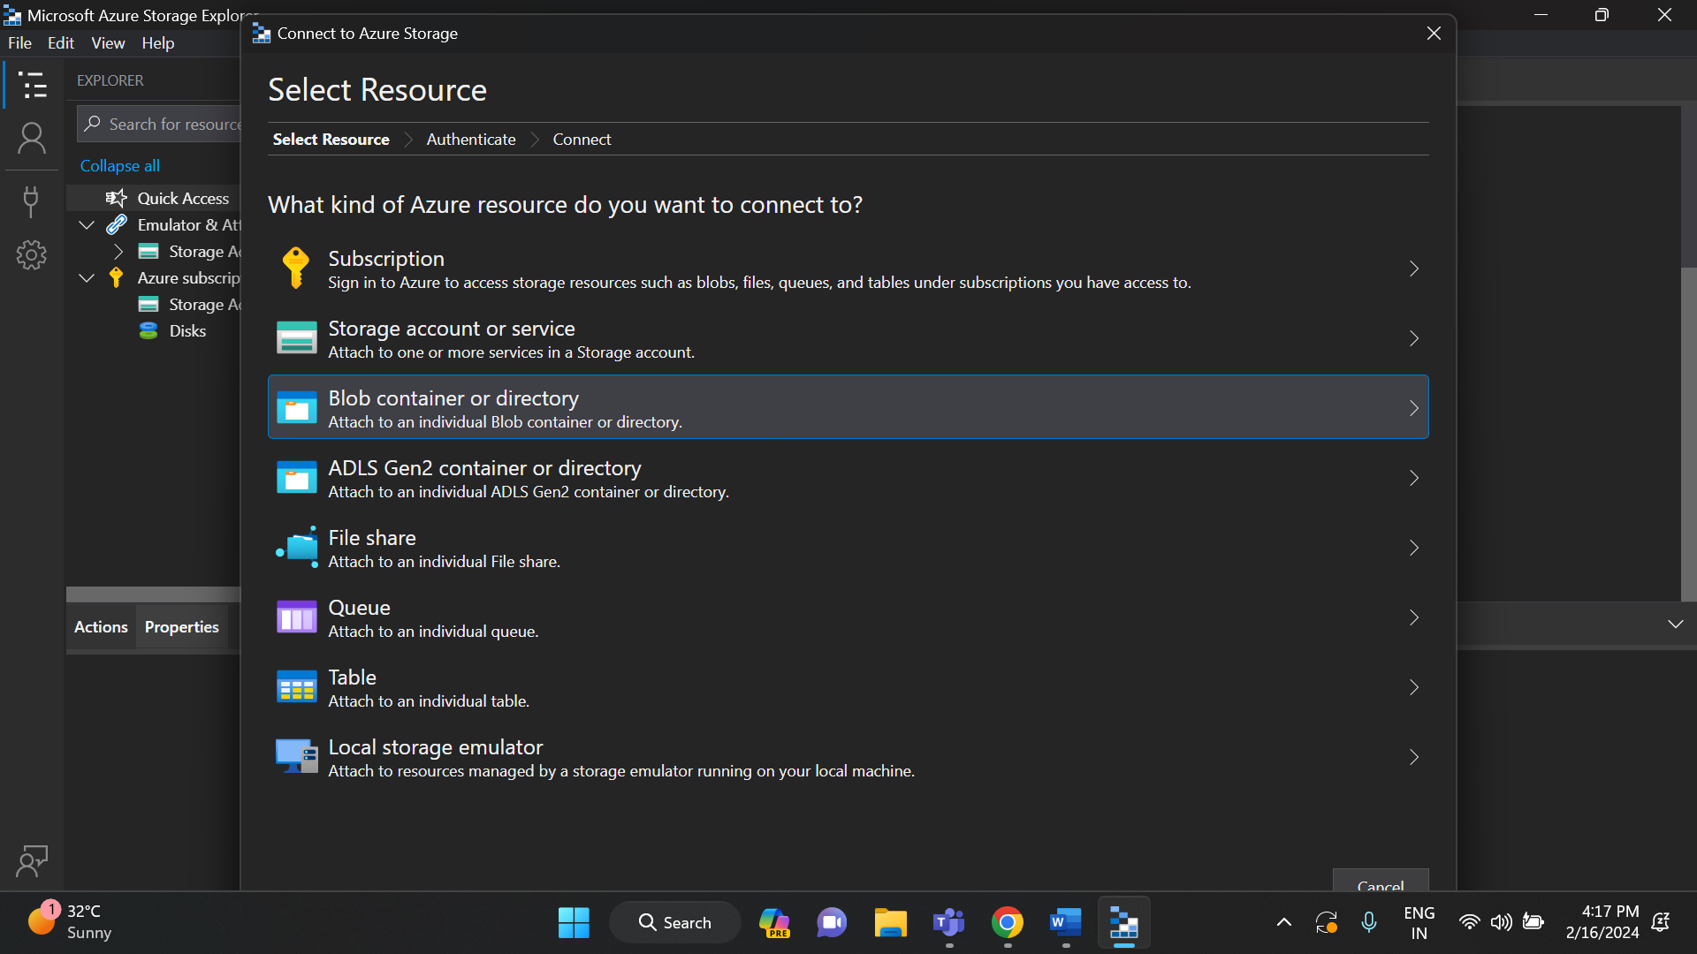

Now, click on shared access signature (SAS) and then press next.

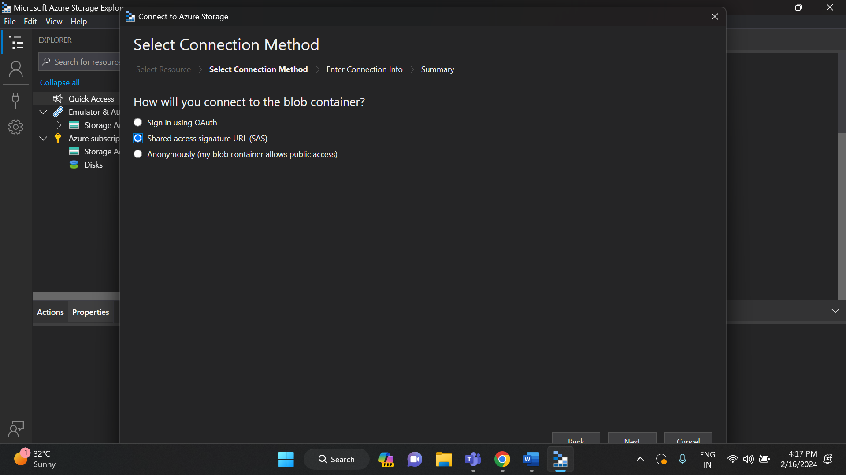

After this step, we need to go to azure portal and then search for access keys. In that copy the storage account name and connection string.

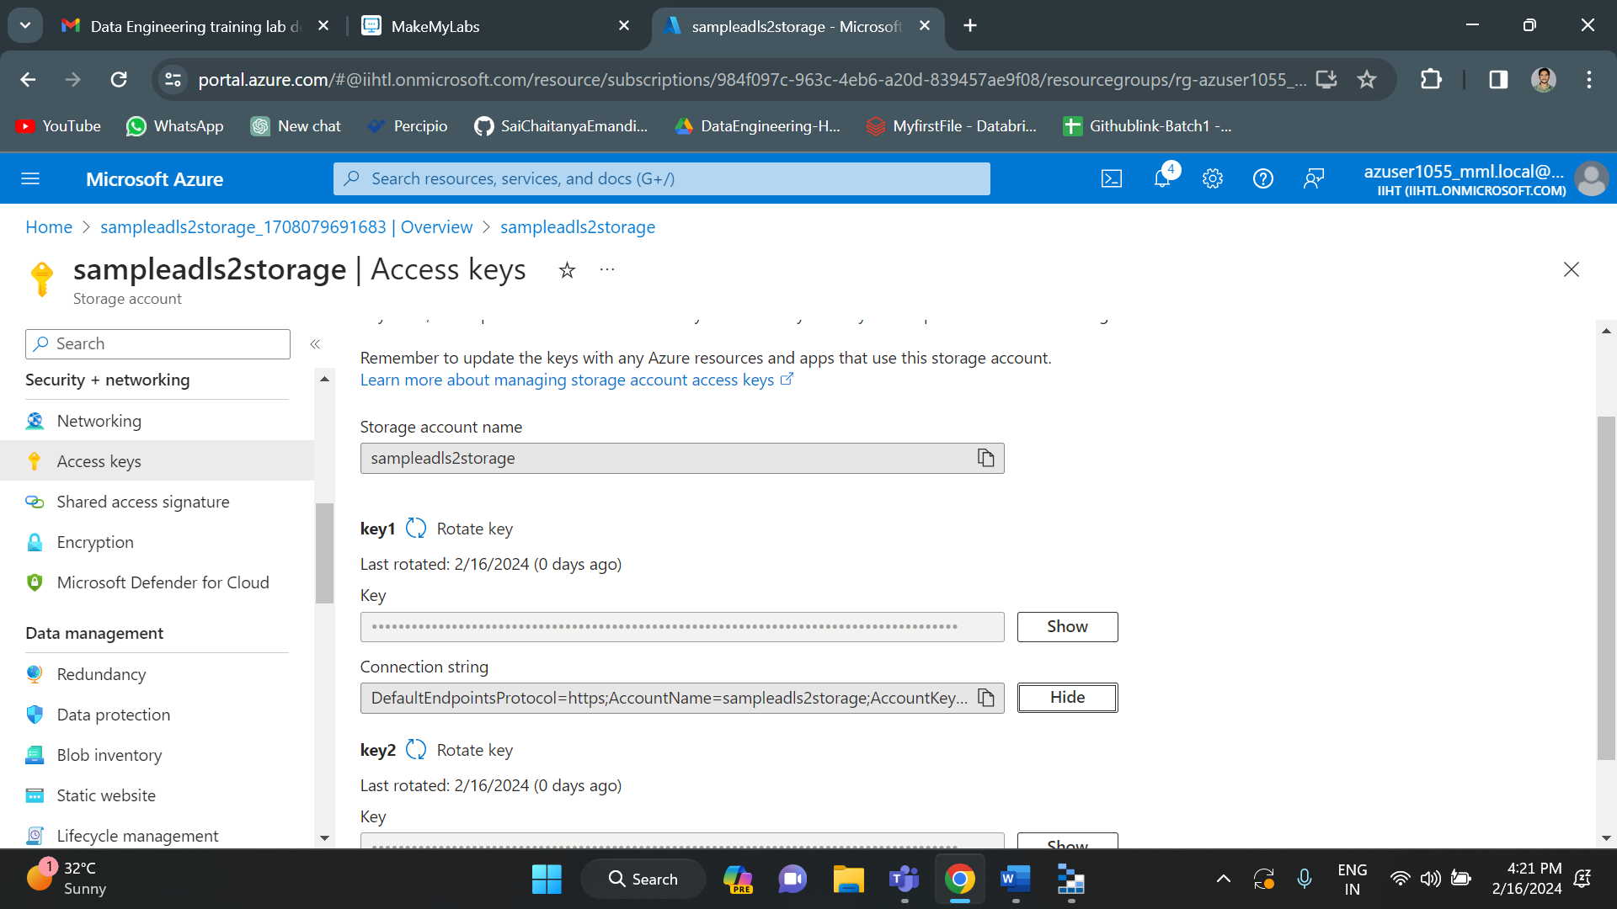

Copy and paste those storage account name and connection string in storage explorer. Click next.

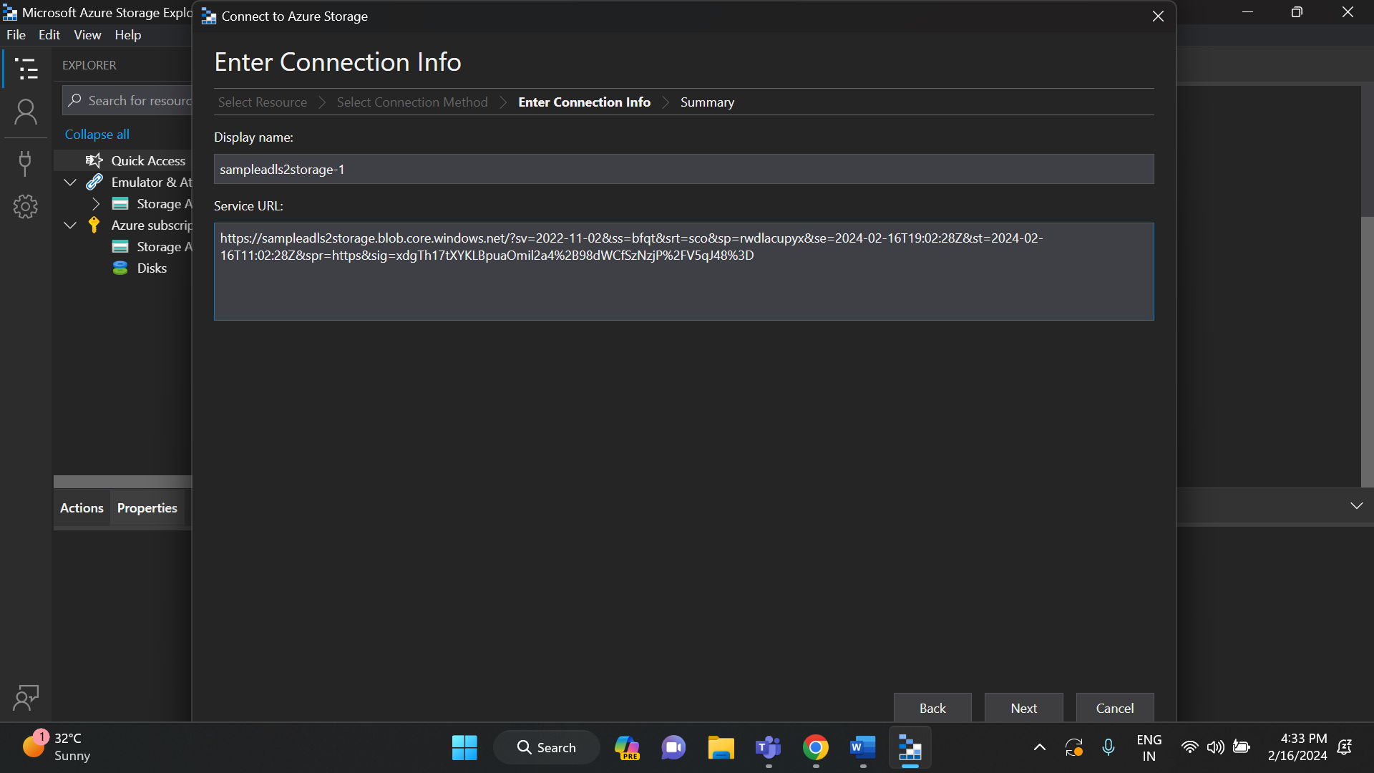

Finally click connect.

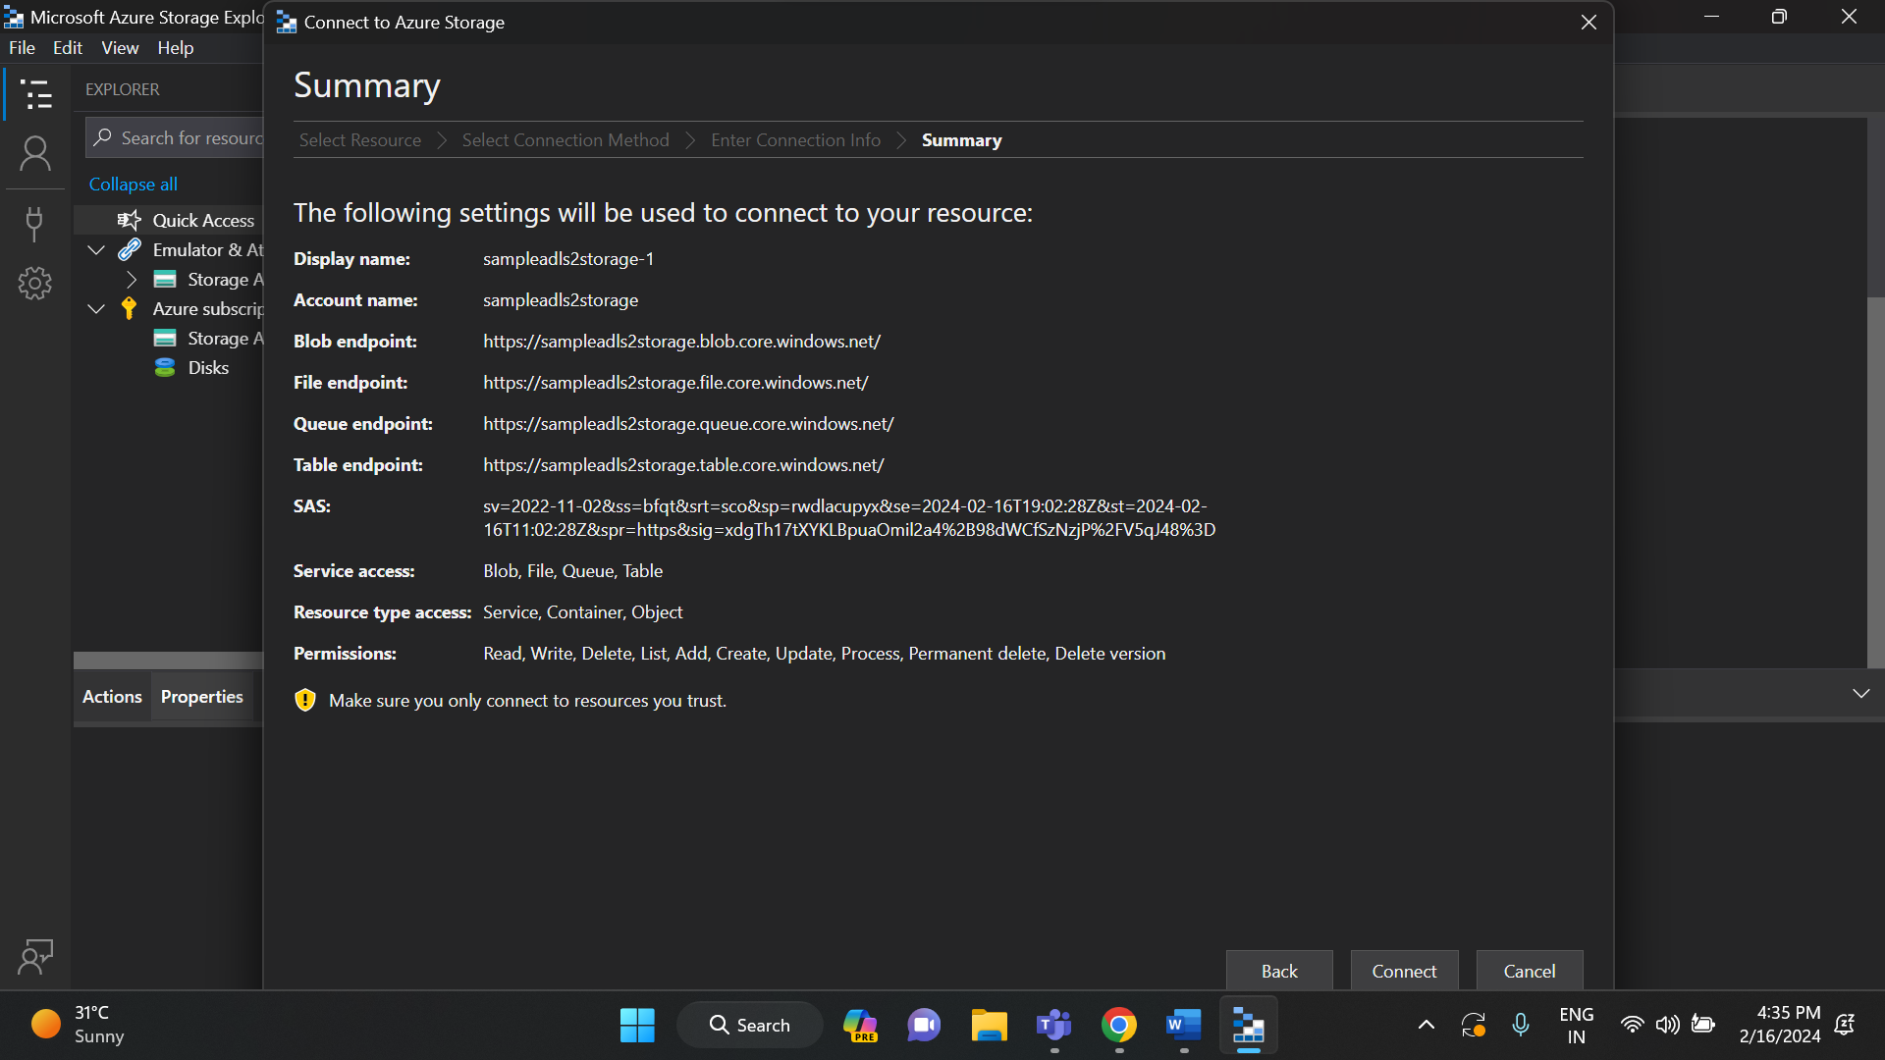

Now we can simply upload files from our local Microsoft azure storage explorer. Any changes here will get updated in the azure storage account.

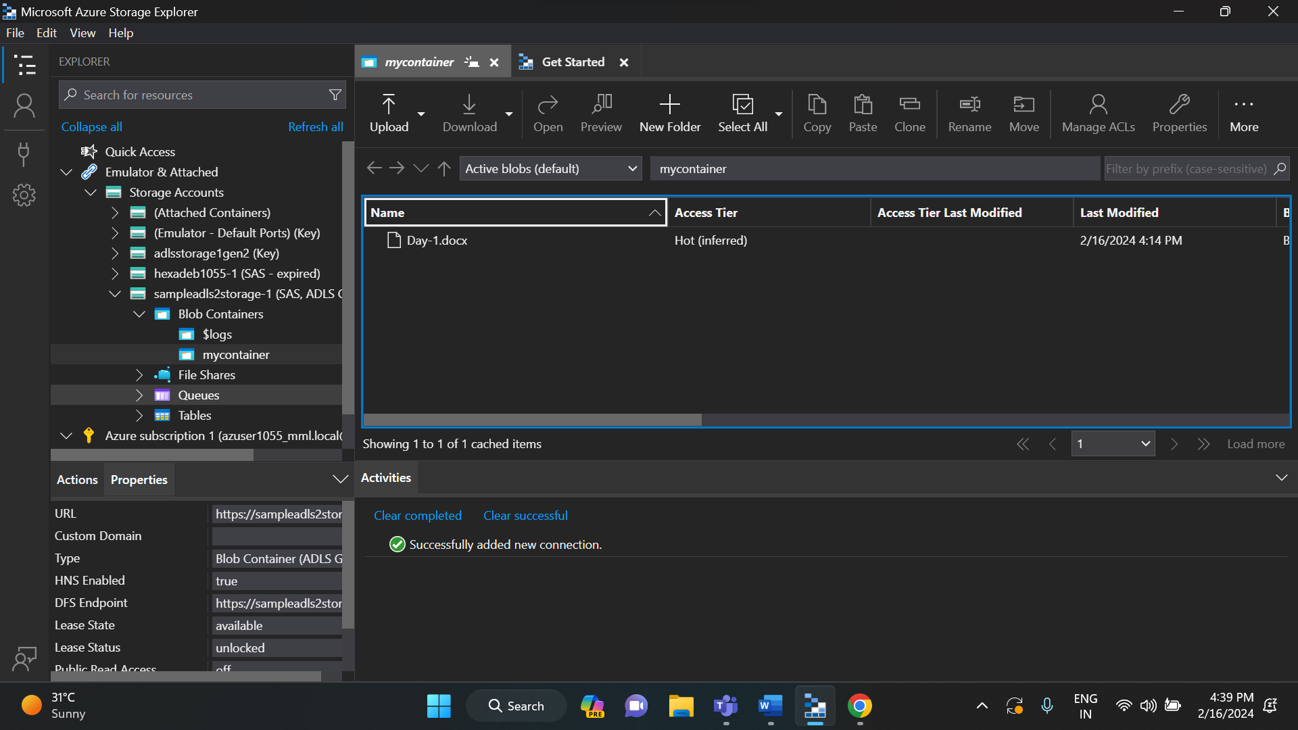

As you can see, in the left side under storage accounts we have all the storage accounts created. I have opened samplealds2storage1. In that, under blob containers, we have our created container. And on clicking it, it shows all the files that are present in the container.

So, this is how to create and connect a azure storage account to local Microsoft azure storage explorer.

**HAND WRITTEN NOTES:**

